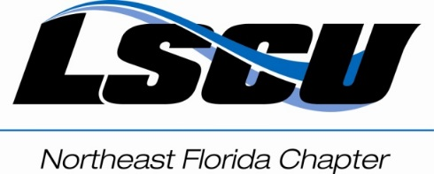

League of Southeastern Credit Unions
Official Filing Form
For
Chapter Directors

To: NEFL Chapter, LSCU

From:

This is to certify that I am a member of an affiliated Credit Union of the League of Southeastern Credit Unions, and I am a Credit Union official or employee of an affiliated Credit Union; and it is my desire to officially file for the Board of Directors of the Northeast Florida Chapter of LSCU.

My qualifications for this office are as follows:

My Credit Union experience is as follows:

My Chapter and/or League experience is as follows:

________________________________
Signature

